铜陵市2017-2018学年度第二学期高一期末教学质量监测
英 语 试 题 答 案（B卷）
第一部分 听力
1~5 ACAAB 6~10 CBABB 11~15 ACCCA 16~20 CABBC
第二部分 阅读理解
21~25 ABCBD 26 ~30ABADD 31~35 BBABA 36 ~ 40 FAEGC
第三部分 英语知识运用
第一节 完形填空
41-45 BDACD 46-50 BADAB 51-55 DCABD 56-60 CABAD
第二节 语法填空-
61. with 62. where 63. swimming 64. a
65. was 66. came 67. your 68. finally
69. walking 70. days
第四部分：写作
第一节 短文改错
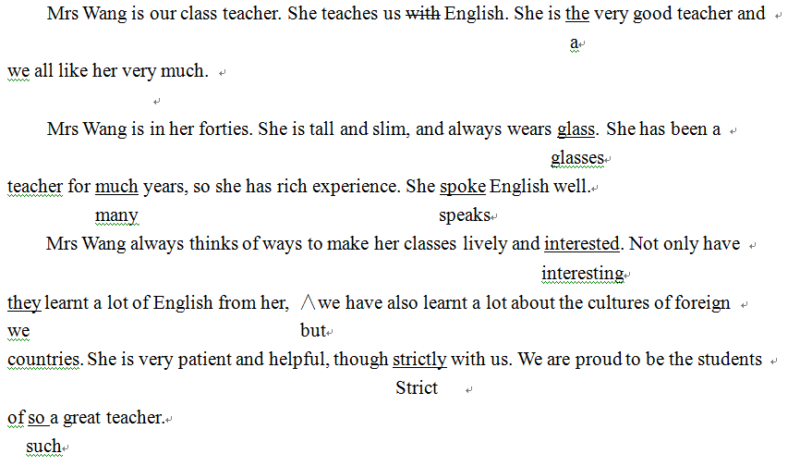
第二节 书面表达
Dear Tom，
It has been a while since my last talk to you, and I would love to answer your questions concerning how math is taught and learnt in our high schools. On the whole, math is one of the most important courses in China, so most schools take it seriously. There are about 7 classes each week. More often than not, the teacher will explain the basic knowledge and ask the students to learn it by heart. In order to help the students learn math well, some more exercises are requested after class. In this way, students can really master the skills of what they’ve learned in class. Apart from this, some students would rather spend extra time studying math further.
In a word, nothing happens by accident. It is because of our devotion to math that we have made great progress on it.
Yours,
Li Hua

