铜陵市2017-2018学年度第一学期高二期末教学质量检测
英 语 试 题 参 考 答 案（B卷）
第一部分 听力（共20小题；每小题1.5分，满分30分）
1~5 BCBAB 6 ~10 ACABB 11~15 BACAB 16 ~20 CCAAC
第二部分 阅读理解（共20小题；每小题2分，满分40分）
21~25 DACDB 26 ~30 DACAB 31~35 CADBC 36 ~ 40 EBCGA
第三部分 英语知识运用
第一节 完形填空（共20小题；每小题1.5分，满分30分）
41-45 DCABA 46-50 DCDAB 51-55 ADCAB 56-60 BDCDC
第二节 语法填空（共10小题；每小题1.5分，满分15分）
61. social 62. has 63. between 64. upsetting 65. what
66. differences 67. a 68. pressed 69. dislike 70. probably
第四部分：写作
第一节 短文改错（共10小题；每小题1分，满分10分）
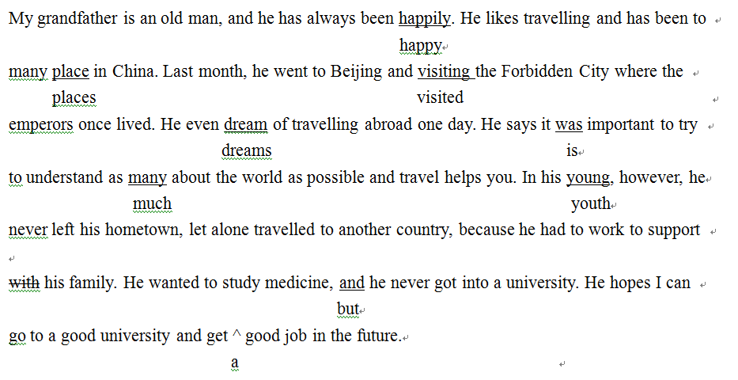
- 书面表达（满分25分）
Dear Sir/Madam,
I'm Li Hua, a senior three student of our school. Knowing that Dream Drama Club is taking in new members, I'm writing to apply for a chance.
First of all, as a crazy learner, I have kept practising spoken English since a young age, so I can express myself freely in English. What's more, years of experience of being monitor makes me a brilliant organizer, which will help a lot with the management of the club. The most important factor is that I love performing, and I used to take an active part in our class plays.
All in all, I think my enthusiasm and full sense of responsibility will make me a qualified club member. I'd appreciate it if you could take my application into consideration.
Yours,
Li Hua

