铜陵市2017—2018学年度第一学期期末质量监测
高一英语试题 参考答案（B）

听力（共20小题；每小题1.5分,满分30分）
1-5 CCAAC 6-10 ABCAC 11-15 BABCC 16-20 BACBC

阅读理解(共20小题；每小题2分，满分40分)
21-23 ACD 24-27 DABA 28-31 BCCD 32-35 BADC 36-40 CFEBD

完形填空(共20小题；每小题1.5分，满分30分)
41-45 ABCDC 46-50 DDABB 51-55 ACDCA 56-60 BDCAB

语法填空（共10小题；每小题1.5分，满分15分）
61. is passed 62.us 63. helping 64.ways 65.which/that
66.and 67.colorful 68.with 69.will be 70.greatly

短文改错（共10小题；每小题1分，满分10 分）
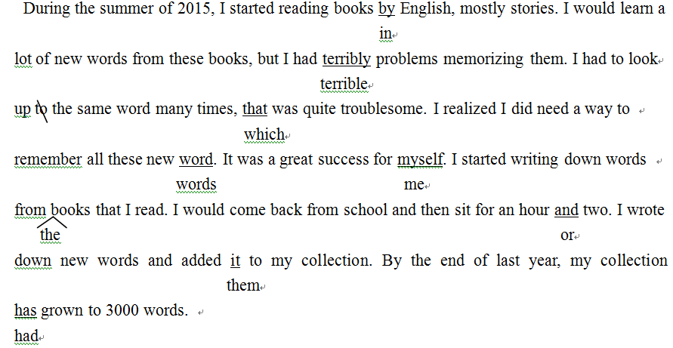
书面表达（满分25分）
One possible version：
Dear Editor,
I am Li Hua, a student of Senior One. I have some trouble in learning English and hope you can give me some useful advice. There is always a long list of new words in my book. I have never learned them before. It is a hard job for me to remember the spelling of them and even the Chinese meanings. So I cannot understand what the English teacher says in class. I become worried and afraid that I will fall behind in English. Could you please give me some advice on how to learn English?
I am looking forward to your early reply.
Best wishes！
Yours sincerely，
Li Hua

